Question 1

# Question a) Provide a box plot and two Q-Q plots for the given data

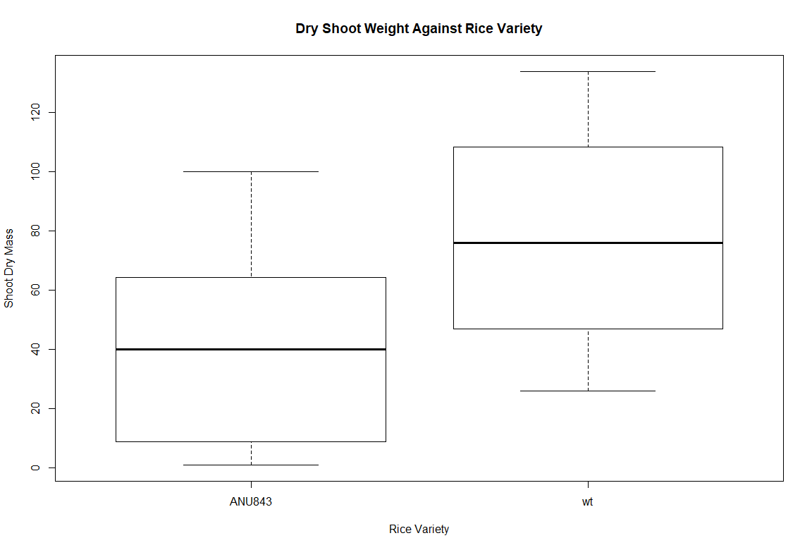

*Boxplot of Shoot Dry Mass for both Rice Varieties*

[Full Size](http://i.imgur.com/P6L5sCC.png)

|  |  |
| --- | --- |
| C:\Users\comma\AppData\Local\Microsoft\Windows\INetCache\Content.Word\qqplot wt.png | C:\Users\comma\AppData\Local\Microsoft\Windows\INetCache\Content.Word\qqplot ANU843.png |
| *Q-Q Plot for wt*  [Full Size](http://i.imgur.com/E1d7R7Q.png) | *Q-Q Plot for ANU843*  [Full Size](http://i.imgur.com/rdy3RSF.png) |

# Question b) Are the t-procedures appropriate for these data?

Yes, the t-procedures are appropriate for use on the given rice data. The boxplots show the data to be reasonable normally distributed without any extreme outliers. The Q-Q plots show the data to fall on a linear Q-Q line reasonably well.

# Question c) Use the appropriate analysis method between Welch’s and pooled t-variance. Provide justification for the choice method of analysis as well as the results of the analysis:

For these data, the Welch’s procedure arguably makes the most sense. Both sets are normally distributed, and the sample sizes are the same. However, the variances of the two sets are different to within a significant margin. Since all the assumptions of the Welch procedure are satisfied, the Welch procedure will provide a good approximation, while because of the difference in variance, the pooled t-variance method may not. To stay on the safe side, I will choose the Welch method.

**Using the Welch un-pooled t-variance procedure in R yields the following results:**

Welch Two Sample t-test

data: wtData$ShootDryMass and ANU843Data$ShootDryMass

t = 4.7559, df = 69.556, p-value = 1.034e-05

alternative hypothesis: true difference in means is not equal to 0

95 percent confidence interval:

20.6111 50.3889

sample estimates:

mean of x mean of y

77.30556 41.80556

# Question d) Provide the null and alternative hypotheses, test statistic, p-value, and conclusion.

**Hypothesis:**

H0: σ12 = σ22 (The variance Shoot Dry Mass for the two varieties of rice is the same)

HA: σ12 ≠ σ22 (The variance Shoot Dry Mass for the two varieties of rice is not the same)

**Test Statistic:**

t = 4.7559

A test statistic of 4.7559 is a very large value, suggesting there may be evidence against H0.

**P-value:**

P-value = 1.034-5

A p-value of less than 0.001 is tiny, offering very strong evidence against the null hypothesis at any meaningful alpha level.

**Conclusion:**

With a p-value of 1.034-5, there is strong evidence against the null hypothesis and therefore strong evidence for the alternative hypothesis. This test shows the mean weight of the Shoot Dry Mass of the two rice varieties is not the same.

# Question e) Interpret the relevant 95% confidence interval

95 percent confidence interval: (20.6, 50.4)

The above confidence interval shows that there is a 95% chance that the true difference in the means of the two rice varieties Shoot Dry Mass lies somewhere between 20.6 and 50.4. By looking at the box plots in question a, this looks to be very reasonable.